Rice Leaf Disease Dataset
About dataset
A dataset of rice leaf images collected (originally) from Mendeley Data, made available via Kaggle for research in rice-leaf disease classification.
Aspect
- Number of images: 5,932 images.
- Plant diversity: Just Rice.
- Number of classes: 4 (Bacterial Blight, Blast, Brown Spot, Tungro)
- Image type: RGB images of rice leaves in JPG format.
- Condition diversity: Wild images.
Conclusion
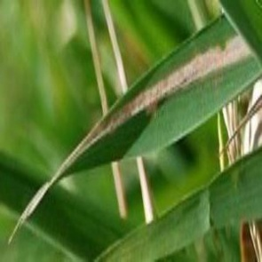
Due to the realistic nature of the images, color augmentation is not recommended. However, this dataset contains just under 6k images, so light data augmentation is enough such as geometric augmentation is recommended. This dataset is intended solely for leaf disease classification tasks.
